**Objekta fotoattēli**

Skats no gājēju tilta uz Vagonu parka pieturas punkta ēku

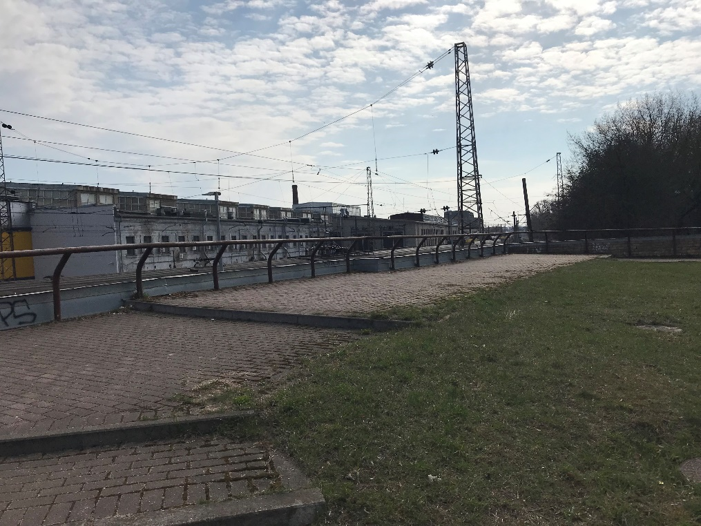

Laukums virs pieturas punkta ēkas

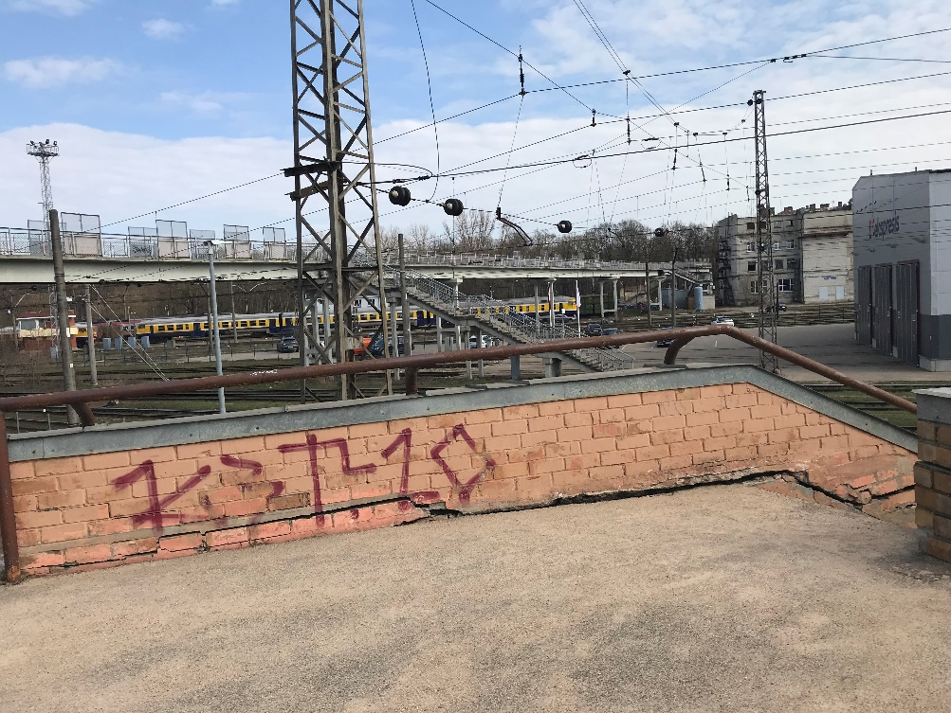

Kāpņu Nr.2 norobežojošā ārmala

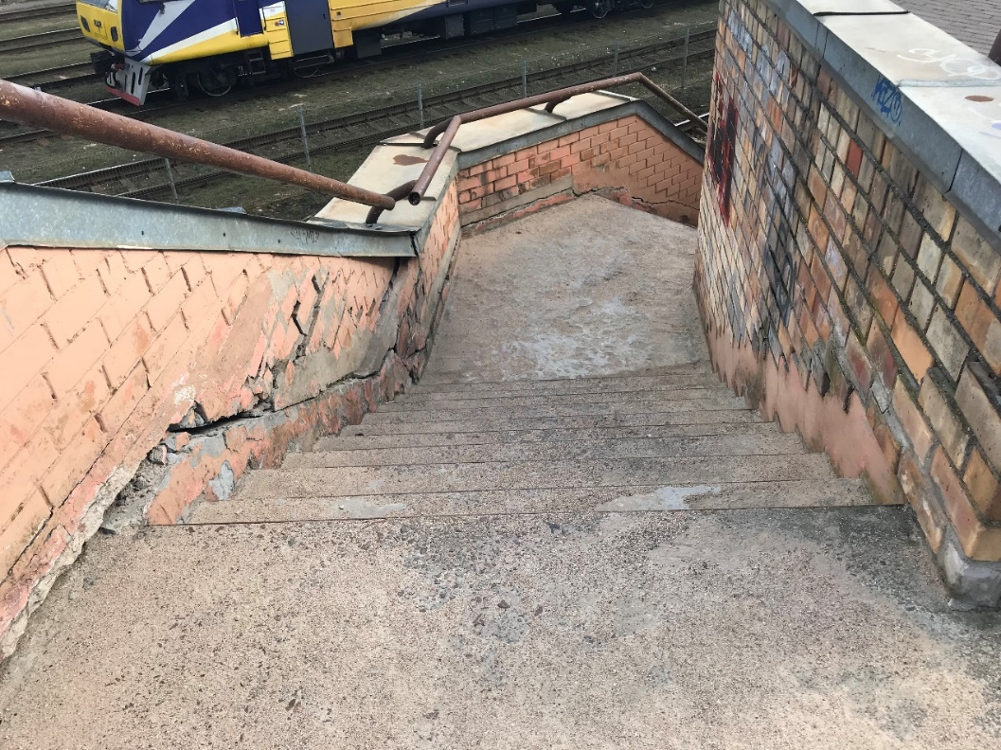

Kāpnes Nr.2

Kāpnes Nr.2

Kāpnes Nr.2

Kāpnes Nr.2

Kāpnes Nr.2

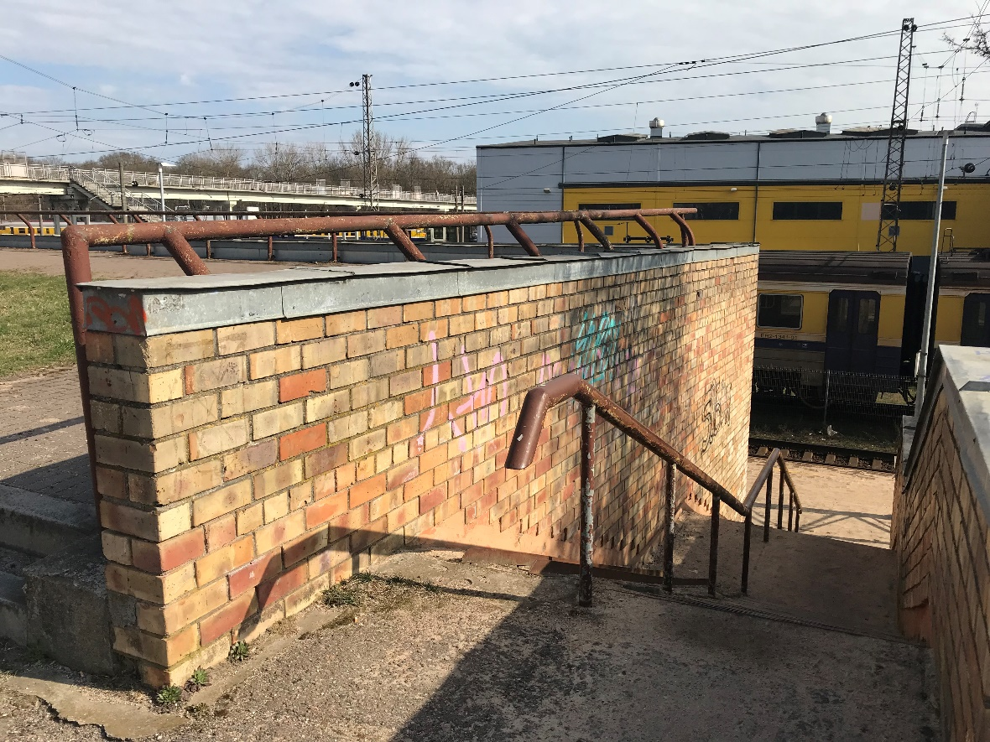

Kāpnes Nr.1

Kāpnes Nr.1

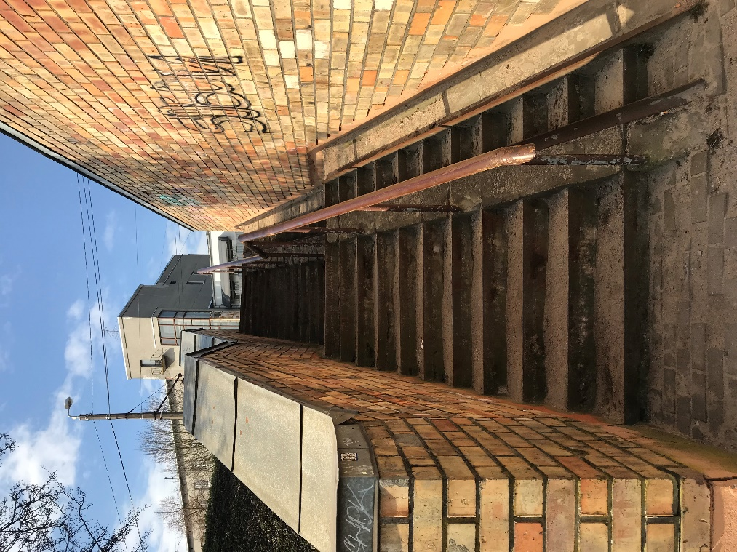

Kāpnes Nr.2

Kāpnes Nr.2

Kāpnes Nr.3

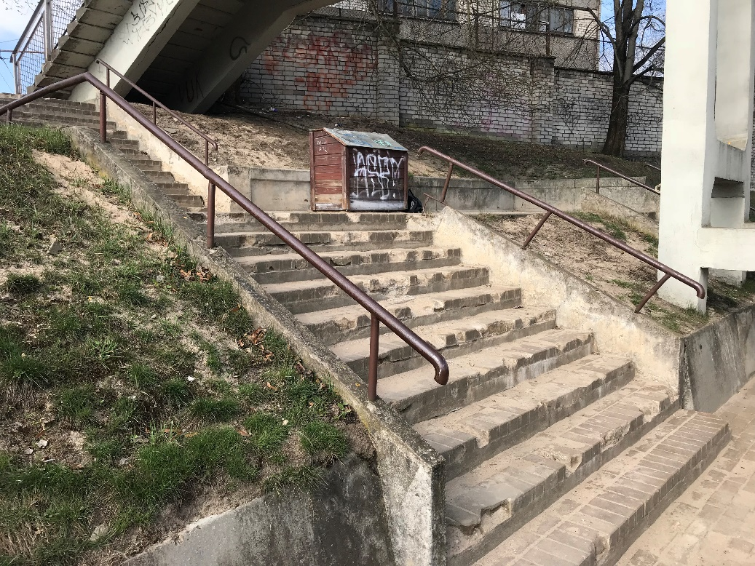

Kāpnes Nr.3

Kāpnes Nr.3

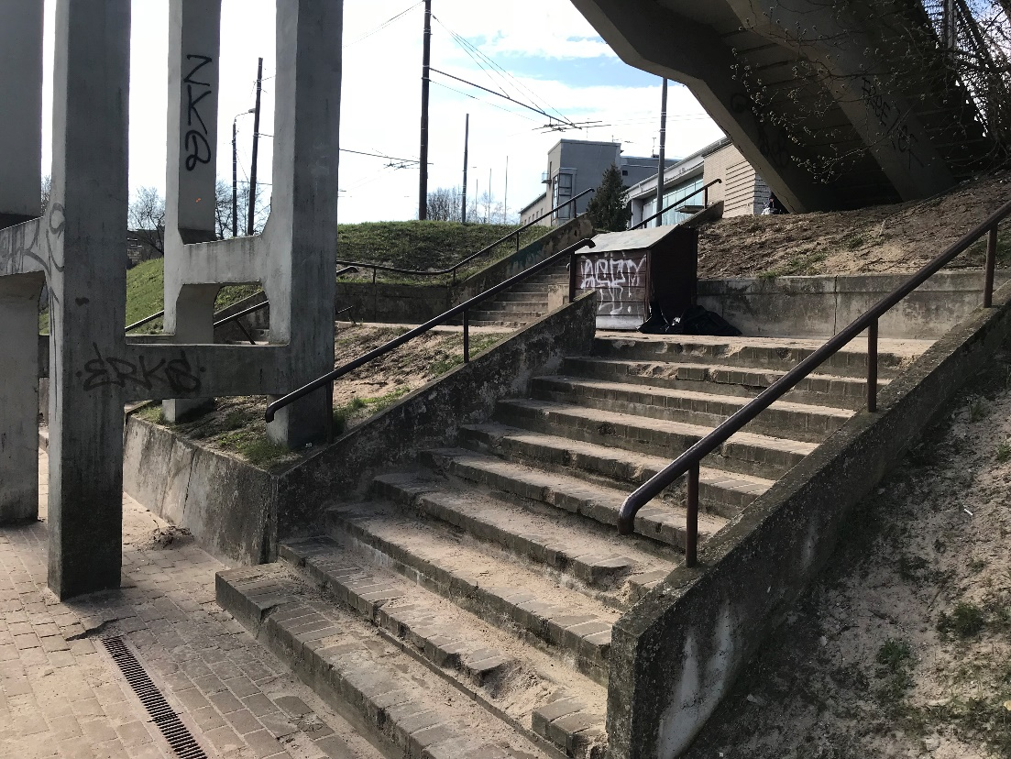

Kāpnes Nr.4