Uzaicinājuma 3.pielikums

**Objekta shēma**

Tīraine-Cena 8.100-32.500

Tīraine - Olaine 8.100 - 19.700 abas puses

|  |  |  |
| --- | --- | --- |
|  |  |  |

|  |  |
| --- | --- |
|  |  |

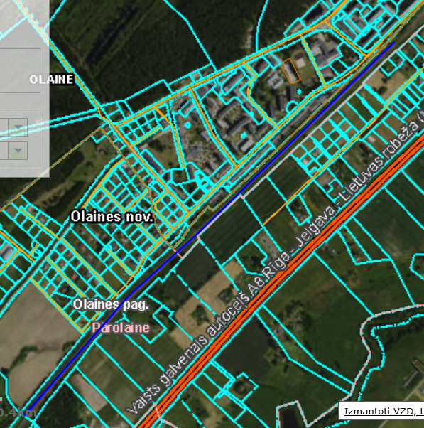

Olaine - Cena 22.400 - 32.500 abas puses

|  |  |
| --- | --- |
|  |  |

