National Customs Board
Latvia

Implementation of Computerised Transit Control System

User Manual
(CTCS-UMN)

Version 0.20

Issue Date: March 26th 2004
DOCUMENT HISTORY

Ed. | Rev. | Date | Description | Pages
0 | 10 | 24/03/2004 | Document Creation. Aligned with current application status.  Submitted for Internal QA Review.  Upon internal QA review, submitted for comments to NCB. | All
0 | 20 | 26/03/2004 | Implementing internal review comments.  Submitted for review to NCB. | I/R

FOR INTERNAL USE ONLY
Prepared by: Nicholas G Mills | Date: 24/03/2004
Reviewed by: Chryssa Nikopoulou, Yota Sarantopoulou | Date: 26/03/2004
Approved by: Gregory Carayannis | Date: 26/03/2004
TABLE OF CONTENTS

1 Introduction 8
1.1 Purpose of the Document 8
1.2 Structure of this Document 8
2 References 9
3 Terminology 10
4 Current Situation 11
4.1 Latvia & NCTS 11
4.2 Traders & NCTS 12
5 Introductory Functions 14
5.1 Login Procedure 14
5.2 Logout 16
5.2.1 Logout Procedure 16
5.2.2 Who Am I 16
5.3 Common Fields, Functions and Procedures 17
5.3.1 Function Buttons 17
5.3.2 Hyperlink Symbols 18
5.3.3 Execution Activity Tree Root and Drilldown Command 20
5.3.4 Field Types 20
6 Detailed Activities 21
6.1 Introduction 21
6.2 Menu Paths 21
6.3 Saving and Modifying Declarations 22
6.4 Reference Numbers 22
6.5 IE Messages for the Trader at Departure 23
6.6 IE Messages for the Trader at Destination 24
6.7 Declaration Types 24
7 Trader at Departure 25
7.1 Trader at Departure Root 25
7.2 Example Trader at Departure Execution Procedures 28
7.2.1 Input Declaration 28
7.2.1.1 Declaration Details 28
7.2.1.2 Traders 31
7.2.1.3 Transport - Location Details 33
7.2.1.4 Seals Guarantee Info 35
7.2.1.5 Goods Items 37
7.2.1.5.1 Goods Items Edit Details 39
7.2.1.5.2 Goods Items Edit More Details 41
8 Trader at Destination 45
8.1 Trader at Destination Root 45
8.2 Example Trader at Destination Execution Procedures 48
8.2.1 Input Arrival Notification 48
8.2.1.1 Movement Details 49
9 Administration 54
9.1 Administration Route 54
9.1.1 Administration Function Buttons 55
9.2 Example Administration Execution Procedures 56
9.2.1 Create New User 56
9.2.2 Manage Existing Group 57
LIST OF TABLES
Table 2-1 Reference Documents 9
Table 3-1: Abbreviations and Acronyms 10
Table 6-1 Movement Status at Departure 23
Table 6-2 Movement Status at Destination 24
Table 6-3 Declaration Types 24
Table 7-1 Input Declaration 29
Table 7-2 Departure Control Result 29
Table 7-3 Departure Customs Office 29
Table 7-4 Destination Customs Office 30
Table 7-5 Transit Customs Office 30
Table 7-6 Goods Total 30
Table 7-7 Authorised Consignee and Representative Sub-Menus 33
Table 7-8 Transport Means 34
Table 7-9 Goods Location 34
Table 7-10 Seals Guarantee 35
Table 7-11 Guarantee Reference 36
Table 7-12 Goods Items 37
Table 7-13 Goods Items 39
Table 7-14 Sensitive Goods 39
Table 7-15 Consignor/Exporter and Consignee Sub-Menus 40
Table 7-16 Goods Items Packages 41
Table 7-17 Produced Certificates and Previous References 42
Table 8-1 Movement Details 49
Table 8-2 En Route Events – Part 1 50
Table 8-3 En Route Events – Part 2 51
LIST OF FIGURES
Figure 4-1 System Architecture 12
Figure 5-1 Logon Page 14
Figure 5-2 Login Procedure 14
Figure 5-3 Trader Route 15
Figure 5-4 Trader Route - Expanded 15
Figure 5-5 Logout - Expanded 16
Figure 5-6 Logout Message 16
Figure 5-7 Who Am I Details 17
Figure 6-1 Trader Route Path 21
Figure 6-2 Trader Root – Write as Session 22
Figure 7-1 Input Declaration Screen 29
Figure 7-2 Completed Input Declaration Screen 31
Figure 7-3 Traders Screen 32
Figure 7-4 Traders Screen - Completed 33
Figure 7-5 Transport - Location Details 35
Figure 7-6 Write as Session Message 35
Figure 7-7 Seals Guarantee Info Screen 37
Figure 7-8 Goods Items 38
Figure 7-9 Goods Items - Edit 40
Figure 7-10 Goods Items - Edit More Details 43
Figure 7-11 Submit Error Message 43
Figure 7-12 Submit Successful Message 44
Figure 8-1 Arrival Notification Details 50
Figure 8-2 En Route Event 51
Figure 8-3 Seals Info 52
Figure 8-4 Arrival Notification Error Message 53
Figure 8-5 Arrival Notification – Message Accepted 53
Figure 9-1 Create New User 56
Figure 9-2 Create New User – Error Message 56
Figure 9-3 Create New User – Correction 57
Figure 9-4 Create New User - Success 57
Figure 9-5 Manage Existing Groups 57
Figure 9-6 Managing Groups 58
Figure 9-7 Add User/Attribute 58
Figure 9-8 Manage Users 59
Figure 9-9 View/Create Trader 59

Introduction

Purpose of the Document
The purpose of this document is to provide the Trader and the Administrator with a comprehensive understanding of the Trader Application execution procedures. It describes all the generic functions that the Trader and the Administrator will use in the day-to-day activities of processing information.

In particular, it describes the execution procedures for the:

- Trader at Departure;
- Trader at Destination;
- The Administration of the Traders.

Structure of this Document
- Section 1 is an introduction to this document.
- Section 2 contains the reference documents.
- Section 3 describes the abbreviations and acronyms used throughout the document.
- Section 4 describes the current and target situation.
- Section 5 describes the Introductory functions, including the Login and Logout procedures. It also includes the common fields, and the generic functions and procedures that the Trader and Administrator will use on a day-to-day basis.
- Section 6 describes the more complex and detailed activities that will be performed by the Trader and/or Administrator.
- Section 7 describes the execution procedures required for the Trader at Departure. This includes a schema that serves as a Trader Root map for each of the respective folders. This table also provides the Trader at Departure with a brief introduction to each of the respective execution procedures.
- Section 8 describes the execution procedures required for the Trader at Destination. This includes a schema that serves as a Trader Root map for each of the respective folders. This table also provides the Trader at Destination with a brief introduction to each of the respective execution procedures.
- Section 9 describes the execution procedures required for the Administration. This includes a schema that serves as a Trader Root map for each of the respective folders. This table also provides the Administration with a brief introduction to each of the respective execution procedures.

References
The reference documents for this Trader Application User Manual are presented below in Table 2-1.

Id | Reference | Title | Version
R1 | FTSS 4_0 including Corr_1_2002 | FTSS 4.00 as amended with Corrigendum 1/2002 | 4.00
R2 | TCE-L1-DDNTA_P31 | DDNTA for Phase 3.1 | 5.00
R3 | CTCS-ICR.v1.00 | Implementation of Computerised Transit Control System – Inception Report | 1.00
Table 2-1 Reference Documents

Terminology
Abbreviation | Description
IE | Information Exchange
LRN | Local Reference Number
MCC | Minimal Common Core
MRN | Movement Reference Number
NCTS | New Computerised Transit System
TAD | Transit Accompanying Document
Table 3-2: Abbreviations and Acronyms

Current Situation
The NCB of Republic of Latvia is a subdivision of the SRS under the Ministry of Finance. Currently NCB is performing all types of Transit.

Latvia’s decision to join the European Union, will substantially affect the work in Customs, since they will need to work in accordance with the standards set by the European Union after the accession date. After joining the EU, Latvian NCB information systems will need to enable a number of EU computerised Customs Systems. The one of the most important systems will include the NCTS.

Currently, the Latvian Customs handle approximately 30,000 declarations per month, involving import/export procedures since Latvia does not belong to the Common Transit Convention. These declarations are mainly paper based and simplified procedures are not used. This scene will drastically change after the accession date, since not only Latvia but also their neighbouring countries Estonia and Lithuania will become European Union Member States.

Currently, the Latvian NCB are preparing the environment so as to be ready by 1st of May 2004. Already before joining the EU, a system of electronic processing of customs declarations should be operational in all customs points, and it should provide facilities for trade to carry out all the necessary customs functions. The use of IT systems in simplified customs and declaration procedures facilitates the work for both customs and trade, it fosters trade, simplifies customs formalities, reduces the number of documents submitted to customs, and reduces time and costs.

With the Trader Application, it will be possible to submit declarations in electronic form and in the near future, an electronic signature system will most probably be introduced that will increase the security of the system. However, this issue is outside the scope of the specific project and therefore, there are not any use cases in the Trader Application User Manual to cover this functionality.

Latvia & NCTS
After the 1st of May 2004, the Customs Services status will change enormously. The International Transit Declarations will be limited to approximately 3,000 per month. There is the possibility for the Railway Organisation to use NCTS as their movements system. Should this be decided, then the Transit Declarations will increase by approximately 50,000 per month. In either case, the need for the Traders to be facilitated with their interaction with the Customs Authorities is still a very important goal for NCB.

It is therefore evident that the NCB has a very difficult and challenging goal; to ensure that by the 1st of May 2004, the NCB will have developed a highly professional integrated system to cover the need to use NCTS, and the need to facilitate the trade in Latvia.

The Customs service has to develop and implement procedures that would facilitate trade by simplifying procedures and decreasing the time and costs involved.

The NCTS system has a number of advantages, most notably:

- Increase efficiency and effectiveness of transit procedures;
- Improve the prevention and detection of fraud;
- Accelerate transactions carried out under a transit procedure and increase security for them;
- Streamline management and administration of transit system.

An overview diagram of the architecture of the NCTS is presented below in Figure 4-1.

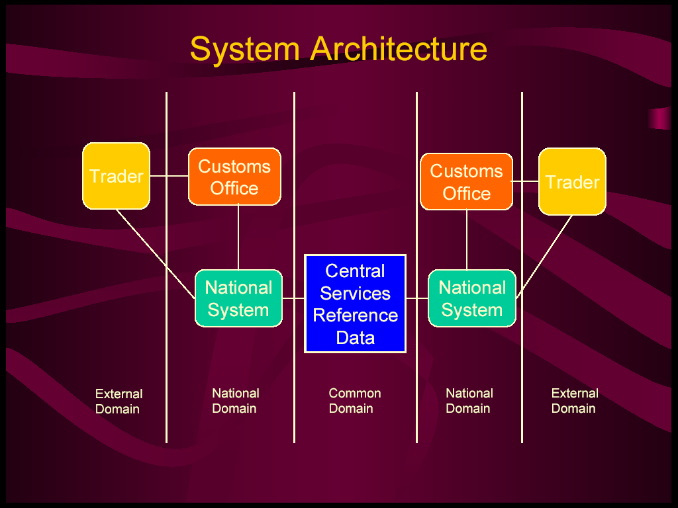
Figure 4-1 System Architecture

Traders & NCTS
Since the 1st of July 2003 it is possible to submit transit declarations to the NCTS electronically. With effect from 31st March 2004, all transits will have to be submitted electronically on NCTS.

An authorised Trader who is approved to use the Simplified Procedure for transit must be able to connect through to the NCTS. He/she also must be in a position to submit their transit declaration electronically and print out the transit declaration in the required format.

A Trader who uses the Normal Procedure (i.e. an unauthorised Trader) may also obtain approval to connect into NCTS, and to input the transit details into the system. An unauthorised Trader will not be able to issue a TAD, but must present himself/herself to customs that, on completion of the necessary checks, will issue this TAD. There is a second option for an unauthorised Trader, and that is to present paper documents to Customs, where the details will then be input into NCTS and the TAD produced by NCTS.

Paper transits will only be allowed in exceptional circumstances after the 31st March 2004.

The Latvian NCB has also decided to include any Trader that operates under normal procedures, to use the same Trader module to submit declarations, communicate information and receive responses.

The Movement Reference Number (MRN) and Local Reference Number (LRN) will be the major keys used to send/receive information. The Web-based Trade module will provide the facilities to allow the Trader to:

- Key in Transit Declarations;
- Upload Transit declaration files generated offline;
- View online the NCTS response messages;
- Use the web interface to communicate requests and receive responses from/by the NCTS.

A Trader authorised to use Simplified NCTS Procedure (Authorised Traders), will be able to print the TAD at his/her premises.

Introductory Functions
In this section, both the Administrator and the Trader are provided with the basic understanding of the most common execution procedures contained within the Trader Application.

Login Procedure
To logon to the Trader Application, the Trader or Administrator should type in the URL in the address bar.This will present the user with the Trader Application Logon page, as shown below in Figure 5-2.

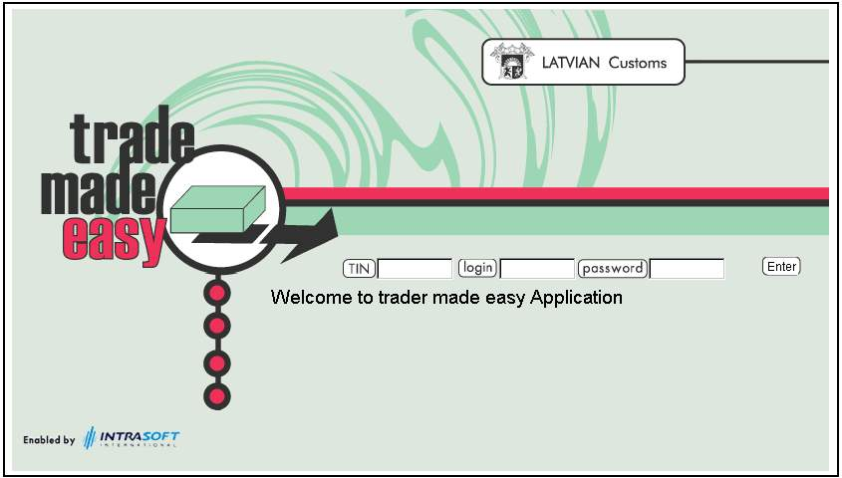
Figure 5-2 Logon Page

The Trader or Administrator is required to enter his/her TIN (Trader Identification Number), and his/her assigned Login and Password, as shown below in Figure 5-3. Once the user has entered the required data into the 3 fields, he/she should click on the Enter button located to the right hand side of the Password field.

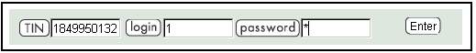
Figure 5-3 Login Procedure

This action will present the Administrator and/or Trader with the Trader Application Home Page. The Trader Root, which enables the user to navigate his/her way through the Trader Application, is located on the left hand side of the screen. As shown below in Figure 5-4, there are 3 basic menu formats within the Trader Root: Trader, Administration and Logout. However, the Administration menu will not be available to the Trader, and so the basic menu format for the Trader will just contain: Trader and Logout.

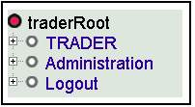
Figure 5-4 Trader Route

It is worth noting that the Administrator determines the exact menu items that will be available to the user when the user is created in the system. It is therefore possible that for a particular user the menu options that are described hereafter might not be available. The Trader can expand the Trader Root to the Trader at Departure and Trader at Destination by clicking on the Trader Action or the Node (+ sign). The Nodes within the Trader Root are located on the left hand side of each Action, Principal Folder and Sub-Folder. This process should be repeated until the Trader/Administrator is able to access the specific Execution Procedure he/she is interested in. The beginning of the Trader Root is marked with a. There after, each subsequent Principal Folder and Sub-Folder is marked with a , and the actual Execution Procedure marked with a , as shown below in Figure 5-5.

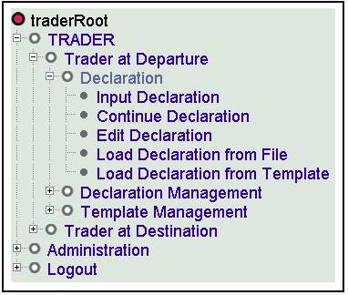
Figure 5-5 Trader Route - Expanded

Logout

As shown below in Figure 5-6, the Logout Folder provides the user with two Execution Procedures. The first procedure enables the Trader/Administrator to Logout of the Trader Application, thus preventing any unauthorised access. The second procedure enables the Trader/Administrator to see his/her Current User details.

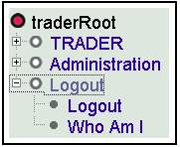
Figure 5-6 Logout - Expanded

Logout Procedure
At the end of the application session, the Trader should click on the Logout execution procedure. As shown below in Figure 5-7, once the Trader/Administrator has executed this step, he/she will be presented with a Logout prompt. Should the Trader/Administrator want to use the Trader Application again, he/she will have to Login again.

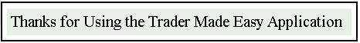
Figure 5-7 Logout Message

If the Trader Application is idle for a period of 30 minutes, the Trader will be returned to the Trader Application Logon page. As a result of this action, the Trader will have to Login once again.

Note: The Trader Application idle time is configurable by the Administrator.

Who Am I
From the Logout Folder, the Trader/Administrator can click on the Who am I procedure, whereupon he/she will be presented with the information as shown below in Figure 5-8.

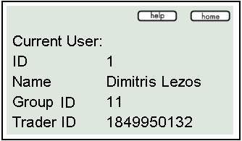
Figure 5-8 Who Am I Details

Common Fields, Functions and Procedures
To maximise the comprehension of the various execution procedures, all the common attributes that are used within the Trader Application are made available in sub-sections 5.3.1, 5.3.2, 5.3.3 and 5.3.4.

Function Buttons
Function | Description
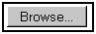 | Searches for a file stored in the user's terminal or other directory, as shown below. These files maybe uploaded to the Trader Application even if these procedures are not declared as Normal or Simplified.  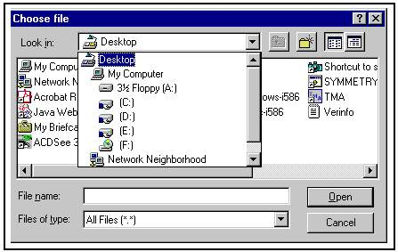
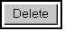 | Deletes the contents from all the fields within the current screen.
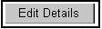 | Enables the Trader to Edit specific values, records and/or fields within the Trader Application.
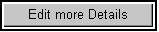 | Enables the Trader to Edit other values, records and/or fields in other related screens within the Trader Application.
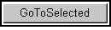 | Synchronises the list box selection with the record pointer.
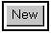 | Enables the Trader to create new fields and records within the Trader Application.
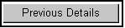 | Returns the Trader to the previously displayed screen.
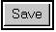 | Saves all new and/or edited data to the Trader Application.
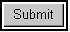 | Submits all the completed fields to the Trader Application.

Hyperlink Symbols
Symbol | Functionality | Description
 | Online Help. | Displays the Online Help menu.
 | Home Page Link. | Returns the Trader to the Trader Root, as shown below whilst maintaining the information on the nodes that where expanded.
 | Displays the pop-up calendar, as shown below.  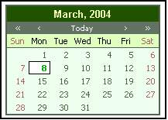 | Displays the selected date in the Year, Month, Day (YYYYMMDD) format, as shown below.  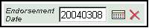
 | Clear field. | Deletes the selected date from the Date field.
3 | Hyperlink in Edit Screens. | Any alphanumeric characters that are coloured Blue and underlined are hyperlinks within the Trader Application. These hyperlinks will present the Trader/Administrator with the selected record, which can be viewed and/or edited accordingly.  For example, in various screens that contain Found Entries, the numbers under the column heading Entry, are the hyperlinks for the respective records.
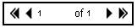 | Displays a selected page. | The double-arrow pointing towards the left displays the first page, whereas the double-arrow pointing towards the right displays the last page.  The single-arrow pointing towards the left displays the previous page, whereas the single-arrow pointing to the right displays the next page.
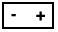 | Deletes and Adds a page. | The Minus (-) symbol deletes the contents of the page displayed and the Plus (+) symbol adds a new page to the existing number of pages currently available.

Execution Activity Tree Root and Drilldown Command
Symbol | Functionality | Description
 | Moves screen up and down. | The Trader can left click the mouse on arrows or click the mouse on the Drill-down command and hold. The screen contents will then move screen up and down the screen. The Drilldown function is located on the right hand side of the screen.
 | Selects another menu/screen within the execution procedure. | By guiding the mouse over the Tree Root, the user can select another Execution menu/screen with the Hand icon. The user should left click the mouse on the Folder symbol that is adjacent to the menu/screen title.  The titles for these menus/screens are located on the left hand side of each Folder symbol within the Tree Root.

Field Types
Font Style and Colour of Field | Condition
Normal and in Red | System Generated and/or Read only
Normal and in Green | Mandatory
Italic and in Green | Dependant
Italic and in Black | Optional

Detailed Activities
This section provides the Trader/Administrator with more detailed activities that are common to the general use of the Trader Application.

Introduction
The Trader Application is a dynamic application, and as such the Trader Root will evolve further during the course of its lifetime. All the currently existing folders, subfolders and their respective execution procedures are given below in further detail in their respective sections. Within each applicable section, the Trader is provided with a brief summary of the actions each execution procedure currently follows.

For all execution procedures within the Trader Application, there are two fundamental procedures, which are known as Simplified and Normal. The Simplified procedure is for Authorised Traders, whilst the Normal procedure is for Unauthorised Traders.

Note: A Trader who processes a Normal procedure cannot issue a TAD (Transit Accompanying Document).

Menu Paths
To access each of the execution procedures, the Trader must follow the path in the Trader Root, as shown below in Figure 6-9. In this example the Trader has selected the following path:

- TRADER;
- Administration;
- User Group Management;
- Manage Existing Groups.

For example, all future paths within the Trader Application user manual will be written with the following convention: Path: TRADER/Administration/User Group Management/Manage Existing Groups.

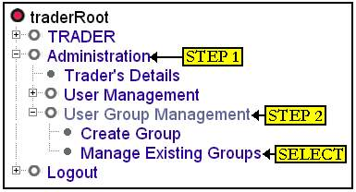
Figure 6-9 Trader Route Path

Saving and Modifying Declarations
At anytime during data input in any of the execution procedures, the Trader may save the information to the Trader Application. To do this and as shown below in Figure 6-10, the Trader must click on the Write as Session function located at the bottom of the Trader Root. This action will enable the Trader to return to the Declaration and further update the declaration details before submitting it to Customs.

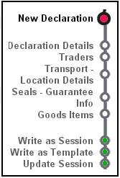
Figure 6-10 Trader Root – Write as Session

When the Trader is ready to update the declarations, he/she can do so via the Continue Declaration execution procedure. On completion of the update, the Trader should click on the Update Session function. This action will replace the original declaration without creating any additional files.

The Write as Template function saves the declaration as a Template. This enables the Trader to retrieve the Template and modify it accordingly in the future and re-use it to create new declarations. The Trader will then be able to save the modified Template as a new Write as Session or Write as Template by clicking on the respective function.

Note: If the Trader executes the Write as Session and/or the Write as Template without updating the declaration, he/she will create a duplicate file.

Reference Numbers
LRNs (Local Reference Numbers) and MRNs (Movement Reference Numbers) are inserted into the Traders declarations automatically. The LRNs contain the 10-digit code that is the specific Trader's TIN (Trader Identification Number), and an algorithm containing an additional 10 digits, such that the LRN is a 20-digit number.

For example: The TIN used within the Trader Application user manual is, 1849950132, and one of the algorithms issued for a declaration is, 0408010078. Hence the LRN for this example is 18499501320408010078.

Note: The sixth digit in the algorithm will either be a 1 or a 0. The numerical value 1 denotes that the LRN is a New Declaration, whereas the numerical value 0 denotes the LRN is a Load Declaration from File. For the above example, the Trader will observe that the LRN is a New Declaration.

IE Messages for the Trader at Departure
Within the Trader at Departure Search Simple/Full Movements, the Trader can select various movements so that he/she can perform various actions which translate to IE (Information Exchange) Message activities (apart from the Print Accompanying Document). Also, and depending on the status of the declaration the Trader can receive various responses. The list of IE Messages applicable to the Trader at Departure are provided below in Table 6-3.

Status | Status Abbreviation | Action (Messages Sent) | IE Message (Message Received)
Submitted | SB | NO ACTION | IE28  IE16
Accepted | AC | Cancellation Request (IE14) | IE60  IE29  IE51  IE09 (Cancel Declaration)
Rejected | RJ | NO ACTION | NO MESSAGE
Released for Transit | RT | Print Accompanying Document in PDF Format | IE45  IE09 (Cancel Declaration)
Not Released for Transit | NT | NO ACTION | NO MESSAGE
Under Control | UC | Cancellation Request (IE14)  Release Request (IE54) | IE51  IE29  IE09 (Cancel Declaration)
Under Release Request | RR | Request Cancellation (IE14) | IE62  IE29  IE51  IE09 (Cancel Declaration)
Under Cancellation Request | CR | NO ACTION | IE09 (Cancel Declaration or Reject Cancellation Request)
Cancelled | CN | NO ACTION | NO MESSAGE
Written Off | WO | NO ACTION | NO MESSAGE
Table 6-3 Movement Status at Departure

IE Messages for the Trader at Destination
Within the Trader at Destination Simple/Full Searches, the Trader can select various movements so that he/she can perform various actions which translate to IE (Information Exchange) Message activities. The list of IE Messages applicable to the Trader at Destination within the execution procedures Simple/Full Searches are provided below in Table 6-4.

Status | Status Abbreviation | Action (Message Sent) | IE Message (Message Received)
Arrival Rejected | AJ | Arrival Notification (IE07) | IE 08
Arrival Reported | AR | No Action | IE 08  IE25
Goods Released | GR | NO ACTION | NO MESSAGE
Table 6-4 Movement Status at Destination

Declaration Types
Within the Input Declaration execution procedure there are five Declaration Types, as described below in Table 6-5. Each Declaration Type has its own specific code, and the Trader should pay particular attention to them. This is because some fields within other menus/screens within the Input Declaration are made Dependant when specific codes are selected.

Declaration Type | Declaration Type Code
Mixed Consignment of T1 and T2 Goods | T-
Goods Moving Under External Communities | T1
Goods Moving Under International Communities | T2
T2 Between Diff.Fiscal.Territ | T2F
See T2 + San Marino | T2SM
Table 6-5 Declaration Types

For example, the condition that follows is applicable in Table 7-22 within Section 7.2.1.5.2, with respect to the Produced Certificates sub-menu in the Goods Items Edit More Details menu/screen.

If the Declaration Type field within the Input Declaration Details menu/screen is T2 or T2F; and if the Country Office of Departure field in the Departure Customs sub-menu within the Declarations Details screen is identified by the first two digits of the Customs Office of Departure Reference Number as being an EFTA or V4 country; then the Previous References sub-menu below is Mandatory, else it is Optional.

Within the contents of Sections 7 and 8, there are a number of additional example Dependant fields, with a clear explanation of the Rules that govern their use or prohibition. For additional information on all the Rules and Conditions, the Trader is recommended to read the Rules and Conditions in the DDNTA for Phase 3.1 – Appendix Q: TMS, Version 6.00-EN.

Trader at Departure
The Trader at Departure section provides the Trader with the specific execution procedures, fields and functions that are necessary for the successful submission of Declarations.

Trader at Departure Root
Currently the Trader at Departure Root exists in the following schema as described below. However, and because the Trader Application is dynamic, this Trader Root is subject to change during the course of its lifetime.

Principal Folder | Sub-Folder | Execution Procedure
Trader at Departure | Declaration | Input Declaration:  The Input Declaration enables the Trader to enter the required information into a series of menus/screens and submit them to Customs. The Trader can also save the incomplete information to be accessed and updated for later use in the Continue Declaration procedure.
Continue Declaration:

Provides the Trader with a screen that contains the following details: the Entry (hyperlink) Number, ID, TIN, Description (if any), Entry Type, Date Submitted and Message Type.

The Entry (hyperlink) Number enables the Trader to access the required Declaration, so that he/she can continue to Input the required information prior to clicking on the Submit button.

Edit Declaration:

The system provides the Trader with a screen in order to be able to locate a previously submitted declaration. The screen displays a list of these declarations with their respective LRNs, Declaration Type, Status and their Status and Submission dates.

Load Declaration from File:

Provides the Trader with a screen enabling him/her to browse for a declaration held on file, as described above in Section 5.3.1

Load Declaration from Template:

Provides the Trader with a screen that contains the following details: the Entry (hyperlink) Number, ID, TIN, Description (if any), Entry Type, Date Submitted and Message Type.

The Entry (hyperlink) Number enables the Trader to access the required Template.

Delete Session:

Provides the Trader with a screen that contains the following details: the Entry (hyperlink) Number, ID, TIN, Description (if any), Entry Type, Date Submitted and Message Type.

When the Trader clicks on the Entry (hyperlink) Number, he/she is prompted with a message that confirms the Traders intention to delete the Session. If the Trader clicks on the OK button, the Session will be deleted from the Trader Application. However, if the Trader clicks on the Cancel button, the Session will not be deleted.
 | Declaration Management | Search Simple Declarations:  Provides the Trader with a screen with seven optional fields. These fields are filter search fields. The more information entered into one or more fields will reduce the number of returned declarations.  If the Trader does not enter information into any of the filter search fields, then the maximum number of declarations will be returned.  Irrespectively of the selected Current Status, the Trader will be able to:  - View a Declaration;  - Copy a Declaration;  - View History;  - View Results.
Search Full Declarations:

Provides the Trader with a screen that has four more optional fields in addition to the seven optional fields made available in the Search Simple Declarations procedure.

The Country of Customs Office of Departure enables the Customs Office of Departure dropdown field to display the Customs Offices of that specific country. Likewise, the Customs Office of Destination dropdown field enables the Customs Office of Destination dropdown field to do the same for the Customs Offices of that specific country. Thus the application makes its query based on the Customs Offices dropdown fields of the specific countries.

These additional fields thus restrict the returned declarations to those of the selected Customs Offices of Departure and Destination.

Irrespective of the selected Current Status, the Trader will be able to:

- View a Declaration;
- Copy a Declaration;
- View History;
- View Results.
 | Template Management | Create Template:  Provides the Trader with a blank Input Declaration procedure. The Trader can either save the blank Input Declaration procedure as a Template, or he/she can perform certain actions within the declaration.  Having done so, he/she should save the resultant Input Declaration Template to the Trader Application by clicking on the Write as Template function located on the Trader Root.
Update Template:

Provides the Trader with a screen that contains the following details: the Entry (hyperlink) Number, ID, TIN, Description (if any), Entry Type, Date Submitted and Message Type.

The Entry (hyperlink) Number enables the Trader to access the required Template, whereupon he/she can update the Template by clicking on the Update Template function.

Delete Template:

Provides the Trader with a screen that contains the following details: the Entry (hyperlink) Number, ID, TIN, Description (if any), Entry Type, Date Submitted and Message Type.

When the Trader clicks on the Entry (hyperlink) Number, he/she is prompted with a message that confirms the Traders intention to delete the Template. If the Trader clicks on the OK button, the Template will be deleted from the Trader Application. However, if the Trader clicks on the Cancel button, the Template will not be deleted.

Example Trader at Departure Execution Procedures
As shown above in the sub-folder Declaration, the Trader at Departure currently has six execution procedures. Within these procedures, there are (in most cases) additional menus/screens, which the Trader must complete before clicking on the Submit button.

Input Declaration
The Input Declaration is the first stage for the movement of goods within the Trader Application. The example given below in this section follows the Simplified procedure, but gives full details on which fields are also applicable to the Normal procedure.

To begin, the Trader must select the path: TRADER/Trader at Departure/Declaration/Input Declaration.

The Trader will observe that the main menu is sub-divided into six sub-menus. The Trader can enter data into any of the six sub-menus in any preferred order. However for the purposes of the Trader Application user manual, the Trader and the Administrator are guided through these procedures in the logical sequence as depicted in the Trader Root.

Thus the Trader should enter the required data in the following sequence.

Declaration Details

Step 1: | From the first menu, the Trader must enter data into the following fields as given below in Table 7-6, and shown below in Figure 7-11.

Field Name | Format | Condition
Local Reference Number | Numeric (20 characters) | Automatic
Declaration Type | Dropdown | Mandatory
Declaration Date | Pop-up | Mandatory
Loading Lists | Numeric (5 characters maximum) | Optional
Declaration Place | Free Text (35 characters maximum) | Mandatory
NCTS Acc/Doc Language | Dropdown | Mandatory
Dialogue Language Indicator | Dropdown | Optional
Table 7-6 Input Declaration

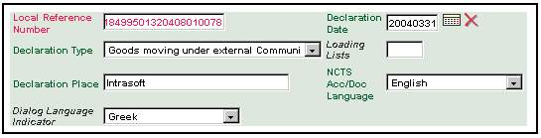
Figure 7-11 Input Declaration Screen

Step 2: | Under the sub-menu Departure Control Result, the Trader should complete the fields as given below in Table 7-7.

Field Name | Format | Condition
Normal/Simplified | Dropdown | Mandatory
Departure Control Result Code | For the Simplified procedure, the code to be entered every time is A3. | Simplified – Mandatory  Normal – Not Applicable
Date Limit | Pop-up | Simplified – Mandatory  Normal – Not Applicable
Table 7-7 Departure Control Result

Step 3: | In the Departure Customs Office sub-menu, the Trader should complete the fields as given below in Table 7-8.

Field Name | Format | Condition
Country of Office of Departure | Dropdown | Mandatory. The Country of Office of Departure enables the Office of Departure dropdown field to display the Customs Offices of that specific country.
Office of Departure | Dropdown | Mandatory
Country of Dispatch | Dropdown | Dependant. If only 1 Country of Dispatch is declared then this field is Mandatory otherwise it cannot be used.  If the Loading Lists field contains a value then this field cannot be used.
Table 7-8 Departure Customs Office

Step 4: | In the Destinations Customs Office sub-menu, the Trader should complete the fields as given below in Table 7-9.

Field Name | Format | Condition
Country of Office of Destination | Dropdown | Mandatory. The Country of Office of Destination enables the Office of Destination dropdown field to display the Customs Offices of that specific country.
Office of Destination | Dropdown | Mandatory
Country of Destination | Dropdown | Optional. If only 1 Country of Destination is declared then this field is Mandatory otherwise it cannot be used.
Table 7-9 Destination Customs Office

Step 5: | In the Transit Customs Office sub-menu, the Trader should complete the fields as given below in Table 7-10.

Field Name | Format | Condition
Country of Transit | Dropdown | Optional. The Country of Transit enables the Office of Transit dropdown field to display the Customs Offices of that specific country.
Office of Transit | Dropdown | Optional
Table 7-10 Transit Customs Office
Step 6: | In the Goods Total sub-menu, the Trader should complete the fields as given below in Table 7-11.

Field Name | Format | Condition
Total Number of Items | Numeric (3 characters maximum) | Mandatory
Total Gross Mass | Numeric (11 characters maximum) | Mandatory
Total Packages | Numeric (7 characters maximum) | Dependant. If the field Loading Lists contains a values then this field is Mandatory otherwise it is Optional.
Container(s) | Check box | Mandatory if the declaration has Containers.
Table 7-11 Goods Total
Once the Trader has completed all the Mandatory fields and any other Optional fields, the Input Declaration screen should look like the example shown below in Figure 7-12.

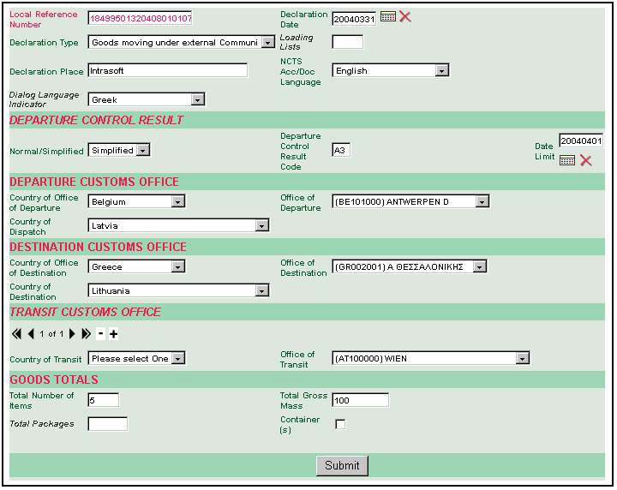
Figure 7-12 Completed Input Declaration Screen
Step 7: | The Trader should now select one of the other execution procedures for data input. For the purposes of this exercise, the chronological sequence of the Trader Root is used. Thus the next execution procedure is the Traders function.

Traders

Step 1: | The Trader should click on the Traders function, which is the second node in the Trader Root. This action will present the Trader with the next execution procedure as shown below in Figure 7-13. As shown at the base of Figure 7-13, the Trader will observe that the Trader Application completes the Principal Detail sub-menu fields automatically.

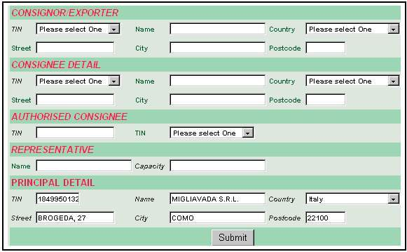
Figure 7-13 Traders Screen

Note: | For Step 2 and Step 3 below, when the Trader selects the TIN from the dropdown fields, the remaining fields are completed automatically.
Step 2: | This group (Consignor/Exporter) is dependant on whether the same Consignor is declared for all goods items. The Trader can select a TIN from the list, in which case the remaining fields are completed automatically. Alternatively the Trader can leave the TIN field blank, but must complete the following fields, because they are Mandatory: Name, Street, City, Country, and Postcode.
Step 3: | If the condition for the Country of Destination is True, the Trader must complete the Consignee Detail sub-menu. If the same Consignee is used for all Goods Items then this section is Mandatory.  If the Trader selects the TIN, the remaining fields are completed automatically. However, and because TIN is Optional, if the Trader does not select the TIN, he/she must complete the remaining fields because they are Mandatory.
Step 4: | The Authorised Consignee sub-menu is optional and can be used to indicate that the Simplified procedure will be used at Destination. The Trader needs to either enter the TIN (Number) or select the TIN (Name) from the dropdown field.
Step 5: | The group Representative is Optional. If required, the Trader should select the required fields (if any) from the Authorised Consignee and Representative sub-menus, as described below in Table 7-12.

Field Name | Format | Condition
Authorised Consignee
The Trader should complete either the TIN or Name, but not both
TIN | Numeric (10 characters maximum) | Optional
Name | Dropdown | Optional.
Representative
Name | Alphanumeric (35 characters maximum) | Optional
Capacity | Alphanumeric (35 characters maximum) | Optional
Table 7-12 Authorised Consignee and Representative Sub-Menus

The completed screen should then resemble the example as shown below in Figure 7-14.

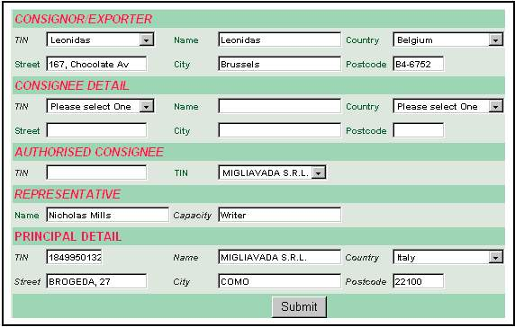
Figure 7-14 Traders Screen - Completed

Step 5: | The Trader should now select one of the other execution procedures for data input. For the purposes of this exercise, the next execution procedure is the Transport - Location Details function.

Transport - Location Details
Within this execution procedure, the Trader should pay particular attention to the Dependant fields and the rules and conditions that validate their usage.

Step 1: | The Trader should now select the Inland Mode and Mode at Border dropdown fields from the Transport Means – Transport Mode sub-menu, as described below in Table 7-12. These fields are Optional, but if selected, the fields within the sub-menus Transport Means – Departure and Transport Means – Crossing Border become Dependant.
Note: | If the Trader does not make a selection from the Inland Mode and Mode at Border fields, the fields within the sub-menus Transport Means – Departure and Transport Means – Crossing Border do not need to be completed.

Field Name | Format | Condition
Transport Means – Transport Mode
Inland Mode | Dropdown | Optional
Mode at Border | Dropdown | Optional
Transport Means – Departure
Identity | Alphanumeric (27 characters maximum) | Dependant on the Inland Mode field. . If the first digit of the Inland Mode field is 5 or 7, then this field cannot be used.
Nationality | Dropdown | Dependant on the Inland Mode field. If the first digit of the Inland Mode field is 2, 5 or 7, then this field cannot be used.
Transport Means – Crossing Border
Identity | Alphanumeric (27 characters maximum) | Optional
Type | Dropdown | Optional
Nationality | Dropdown | Dependant on the Mode at Border field. If the first digit of the Mode at Border field is 2, 5 or 7, then this field is Optional else it is Mandatory.
Table 7-13 Transport Means

Step 2: | The Trader should proceed to enter the required data into the fields within the Goods Location sub-menu, as described below in Table 7-14.

Field Name | Format | Condition
Goods Location
Agreed Location Code | Alphanumeric (17 characters maximum) | Normal - Optional  Simplified - Not Applicable
Agreed Location Goods | Alphanumeric (35 characters maximum) | Normal - Optional  Simplified - Not Applicable
Customs Sub Place | Alphanumeric (17 characters maximum) | Normal - Optional  Simplified - Not Applicable
Authorised Location of Goods Code | Alphanumeric (17 characters maximum) | Simplified - Mandatory  Normal – Not Applicable
Loading Place | Alphanumeric (17 characters maximum) | Optional
Table 7-14 Goods Location
Once the Trader has completed all the required fields, the screen should resemble the example as shown below in Figure 7-15.

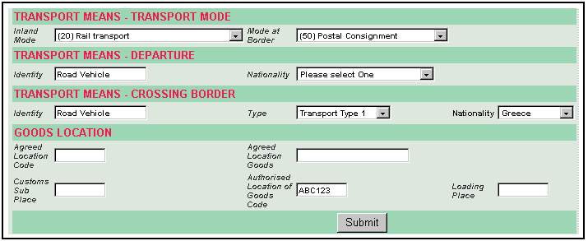
Figure 7-15 Transport - Location Details
Step 3: | The Trader should now click on the Seals Guarantee Info function.
Note: | The Trader can click on the Write as Session function at any time during data input and save the existing details to the Trader Application. When the Trader executes this function, he/she will be prompted with a message that contains the Entry ID number, as shown below in Figure 7-16. This Entry ID number will then enable the Trader to locate the respective file from the Continue Declaration execution procedure.

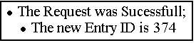
Figure 7-16 Write as Session Message

Seals Guarantee Info
Step 1: | The Seals Info sub-menu is Mandatory if the declaration is submitted under the Simplified procedure; the authorisation of which foresees the use of seals, otherwise under Normal procedure this group is Optional. The Guarantee Group is Mandatory.

Field Name | Format | Condition
Seals Info
Seals Number | Numeric (4 characters must be entered) | Mandatory
Seals ID
Identity | Numeric (20 characters must be entered) | Mandatory
Guarantee
Type | Dropdown | Mandatory
Table 7-15 Seals Guarantee
Step 2: | The Trader should continue with the 3 remaining sub-menus, as described below in Table 7-16.
Note: | The Trader must complete either the Reference Number field, or the Other Guarantee References field. The Trader MUST NOT enter reference numbers into both fields! In the example shown below in Figure 7-17, the Reference Number field has been completed, and the Other Guarantee References field left blank.

Field Name | Format | Condition
Guarantee Reference
Reference Number | Numeric (17 characters must be entered. This is except for the Flat-Rate Voucher in the Type field in the Guarantee sub-menu, as described above in Table 7-15, which must have 24 characters). | Dependant. If the Guarantee Type is one of the following:  - Guarantee Waiver;  - Comprehensive Guarantee;  - Individual Guarantee;  - Flat-rate Voucher; or  - Individual Guarantee with multiple;  Then this field is Mandatory otherwise it is Optional.
Other Guarantee References | Numeric (35 characters must be entered) | Mandatory
Access Code | Numeric (4 characters must be entered) | Dependant. If the Guarantee Type is one of the following:  - Guarantee Waiver;  - Comprehensive Guarantee;  - Individual Guarantee;  - Flat-rate Voucher; or  - Individual Guarantee with multiple;  - And the attribute GRN (NCTS Guarantee Reference Number) is Used;  Then this field is Mandatory otherwise it is Optional.
Validity Limitation EC
Not Valid for EC | Check-box | Optional
Validity Limitation Non-EC
Not Valid for Other Contracting Parties | Dropdown | Optional
Table 7-16 Guarantee Reference

The completed Seals Guarantee Info screen should resemble the example as shown below in Figure 7-17.

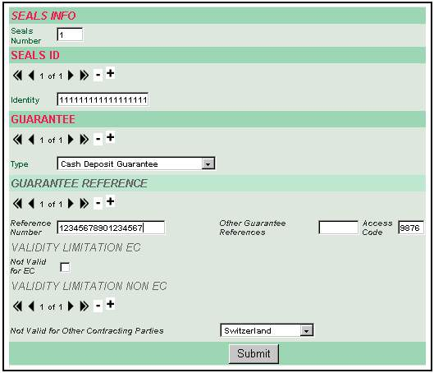
Figure 7-17 Seals Guarantee Info Screen
Step 3: | The Trader should now click on the Goods Items function, as described below in Section 7.2.1.5.

Goods Items
Step 1: | The Trader must enter the required information into the Goods Item field, and complete the Goods Description field, as described below in Table 7-17.

Field Name | Format | Condition
Goods Item | Numeric (5 characters maximum) | Mandatory
Goods Description | Alphanumeric (260 characters maximum) | Mandatory
Table 7-17 Goods Items
Note: | Each time the Trader wants to add additional Goods Items, he/she should click on the Plus (+) sign located above the Goods Item field, as shown below in Figure 7-18. This action will permit the Trader to repeat the procedure as outlined above in Step 1 of this section. When the Trader clicks on the Go To Selected button, the application will display the selected goods that are highlighted by the Blue cursor.

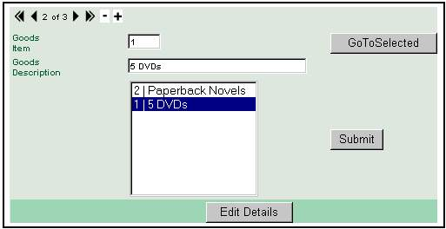
Figure 7-18 Goods Items

Step 2: | Once the Trader has entered the required data, he/she should click on the Edit Details button. This action will present the Trader with the first of two Goods Edit Menus. Following their completion, the Trader will then be in a position to submit the declaration to the MCC client.

Goods Items Edit Details

Step 1: | Enter the required data into the Good Items sub-menu, as described below in Table 7-18.

Field Name | Format | Condition
Number | Numeric (5 characters maximum) | Mandatory
Declaration Type | Dropdown | Dependant. If the Declarations Type field in the Input Declarations menu/screen contains the following type, Mixed Consignment of T1 and T2 Goods;  Then this field is Mandatory otherwise it cannot be used.
Gross Mass | Numeric (11 characters maximum) | Optional
Net Mass | Numeric (11 characters maximum) | Optional
Country of Dispatch | Dropdown | Dependant. If only one Country of dispatch is declared, then this field is Mandatory otherwise it cannot be used.
Country of Destination | Dropdown | Dependant If only one Country of Destination is declared, then this field is Mandatory otherwise it cannot be used.
Commodity Code | Dropdown | Dependant. If the SGI-CODES is used, then this field is Mandatory otherwise it is Optional;  And, in the case that this declaration is under the Simplified procedure, the data group Control Results must be present.
Description | Alphanumeric (260 characters maximum) | Mandatory
Table 7-18 Goods Items
Step 2: | Continue as before for the Sensitive Goods sub-menu, as described in Table 7-19. This group is required if the declaration contains sensitive goods.

Field Name | Format | Condition
Code | Dropdown | Dependant. If the Declaration contains Sensitive Goods, then this field is Mandatory otherwise it is Optional.
Quantity | Numeric (11 characters maximum) | Mandatory
Table 7-19 Sensitive Goods

Step 3: | Continue as before for the Consignor/Exporter and Consignee sub-menus, as described below in Table 7-20. The Trader will observe that whereas the TIN is an Optional field, if this field is selected, all the remaining fields are completed automatically. These groups are Mandatory if there are different Consignor/Consignees for the items.

Field Name | Format | Condition
Consignor/Exporter and Consignee Sub-Menus
TIN | Dropdown | Optional
Name | Alphanumeric (35 characters maximum) | Mandatory
Country | Dropdown | Mandatory
Street | Alphanumeric (35 characters maximum) | Mandatory
City | Alphanumeric (35 characters maximum) | Mandatory
Postcode | Alphanumeric (9 characters maximum) | Mandatory
Table 7-20 Consignor/Exporter and Consignee Sub-Menus

With all the required fields completed, the resultant screen may resemble the example as shown below in Figure 7-19.

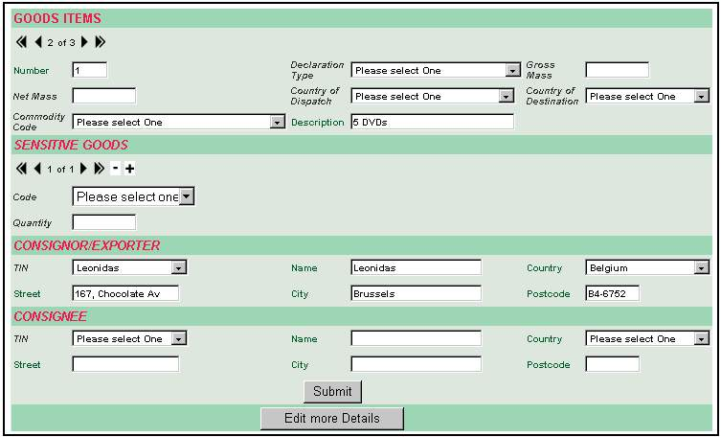
Figure 7-19 Goods Items - Edit

Step 4: | The Trader should click on the Edit More Details button to proceed to the final Input Declarations screen, as described below in Section 7.2.1.5.2.

Goods Items Edit More Details

Step 1: | This is the final screen in the Input Declarations execution procedure, and as described below in Table 7-21, the Trader should enter all the required data into the specific and applicable fields.

Field Name | Format | Condition
Goods Items Packages
This sub-menu cannot be used when the field Loading Lists contains a value
Type | Dropdown | Mandatory
Marks and Numbers | Alphanumeric (42 characters maximum) | Dependant. If the Type field indicates Bulk, then this field is Optional
Number of Packages | Numeric (5 characters maximum) | Dependant. If the Type field indicates Bulk, then this field cannot be used.
Number of Pieces | Numeric (5 characters maximum) | Dependant. If the Type field indicates Bulk, then this field cannot be used.
Containers
This must be present in at least one Goods Item if the field Container(s) has been completed
Number | Numeric (17 characters maximum) | Mandatory
Special Mentions
Additional ID | Dropdown | Optional. The Trader must complete either the Additional ID or Additional Information fields, but not both.
Additional Information | Alphanumeric (70 characters maximum)
EC Export | Check-box | Dependant on the Additional ID field in the Special Mentions sub-menu. If the Additional ID field is DG0 or DG1, then this field is Mandatory, else this field cannot be used.
Country Export | Dropdown | As above for EC Export
Table 7-21 Goods Items Packages

Step 2: | As described below in Table 7-22, the Trader should enter the required data into either the Produced Certificates or Previous References sub-menus. If the Produced Certificates sub-menu is used, one of the three fields will have to be completed.

Field Name | Format | Condition
Produced Certificates
Type | Dropdown | If the Declaration Type field within the Input Declaration Details menu/screen is T2 or T2F; and if the Country Office of Departure field in the Departure Customs sub-menu within the Declarations Details screen is identified by the first two digits of the Customs Office of Departure Reference Number as being an EFTA or V4 country; then the Previous References sub-menu below is Mandatory, else it is Optional.
Reference | Alphanumeric (20 characters maximum) | Optional (See Step 2).
Complement of Information | Alphanumeric (20 characters maximum) | Optional (See Step 2).
Previous References Sub-Menus
The group is Dependant on both the Declaration Type field in Declaration Details screen; and Country Office of Departure field in the Departure Customs sub-menu within the Declarations Details screen.
Type | Dropdown | Mandatory
Reference | Alphanumeric (20 characters maximum) | Mandatory
Complement of Information | Alphanumeric (20 characters maximum) | As above for the Type and Reference fields within the Previous References sub-menu.
Table 7-22 Produced Certificates and Previous References

The final screen requiring data input for the Input Declarations execution procedure should therefore resemble the example as shown below in Figure 7-20.

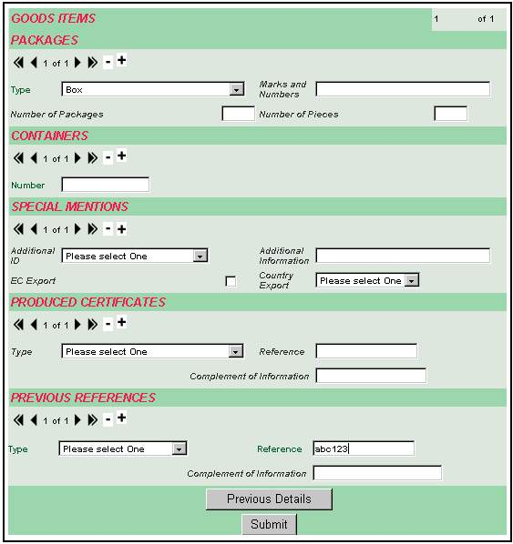
Figure 7-20 Goods Items - Edit More Details
Step 3: | The Trader having completed all the required fields should now click on the Submit button. However, if the Trader has made an error during the Input Declaration procedure, he/she will be prompted with an error message, as shown below in Figure 7-21.

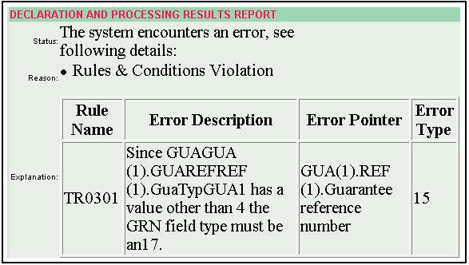
Figure 7-21 Submit Error Message
Note: | If the Trader Application returns an error message when the Trader clicks on the Submit button, it may return two types of error messages. The one shown above in Figure 7-21 is a Rules and Conditions Violations Error Message. Whereas the error message shown further below in Figure 8-26 is a Schema Validation Error Message.

Step 4: | Once the trader has corrected his/her Input Declaration error(s), he/she should click on the Submit button once again. If the submission is successful, the trader Application will prompt the Trader with a Message informing him/her that the message was accepted, as shown below in Figure 7-22.

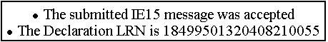
Figure 7-22 Submit Successful Message

Trader at Destination
This section provides the specific execution procedures, fields and functions that are necessary for the successful movement of goods between the Office of Departure and the Office of Destination.

Trader at Destination Root
Currently the Trader at Destination Root exists in the following schema as described below. However, as mentioned above in Section 7.1, and because the Trader Application is dynamic, this Trader Root is also subject to change during the course of its lifetime.

Principal Folder | Sub-Folder | Execution Activity
Trader at Destination | Arrival Notification | Input Arrival Notification:  Provides the Trader with a screen whereupon he/she can enter the required information into the two menus/screens: Arrival Notification Details and En Route Events.  This execution procedure is described below in more detail in Section 8.2.1.
Continue Arrival Notification:

Provides the Trader with a screen that contains the following details: the Entry (hyperlink) Number, ID, TIN, Description (if any), Entry Type, Date Submitted and Message Type.

The Entry (hyperlink) Number enables the Trader to access the required Arrival Notification, so that he/she can continue to Input the required information prior to clicking on the Submit button

Edit Arrival Notification:

The system provides the Trader with a screen in order to be able to locate a previously saved declaration that the specific Trader (TIN) has created and saved. The screen displays a list of these declarations with their respective LRNs, Declaration Type, Status and their Status and Submission dates.

Load Arrival Notification from Template:

Provides the Trader with a screen that contains the following details: the Entry (hyperlink) Number, ID, TIN, Description (if any), Entry Type, Date Submitted and Message Type.

The Entry (hyperlink) Number enables the Trader to access the required Arrival Notification from Template.

Delete Session:

Provides the Trader with a screen that contains the following details: the Entry (hyperlink) Number, ID, TIN, Description (if any), Entry Type, Date Submitted and Message Type.

When the Trader clicks on the Entry (hyperlink) Number, he/she is prompted with a message that confirms the Traders intention to delete the Session. If the Trader clicks on the OK button, the Session will be deleted from the Trader Application. However, if the Trader clicks on the Cancel button, the Session will not be deleted.

 | Movement Management | Search Simple Movements:  Provides the Trader with a screen with five optional filter search fields. The more information entered into one or more fields will reduce the number of returned declarations.  If the Trader does not enter information into any of the filter search fields, then the maximum number of declarations will be returned.  Irrespectively of the selected Current Status, the Trader will be able to:  - View a Movement;  - Copy a History;  - View Results;  - View Arrival Notification.
 | Movement Management | Search Full Movements:  Provides the Trader with a screen that has four more optional fields in addition to the five optional fields made available in the Search Simple Declarations procedure.  The Country of Customs Office of Departure enables the Customs Office of Departure dropdown field to display the Customs Offices of that specific country. Likewise, the Customs Office of Destination dropdown field enables the Customs Office of Destination dropdown field to do the same for the Customs Offices of that specific country.  Thus the application makes its query based on the Customs Offices dropdown fields of the specific countries.  These additional fields thus restrict the returned declarations to those of the selected Countries of both Departure and Destination.  Irrespective of the selected Current Status, the Trader will be able to:  - View a Movement;  - Copy a History;  - View Results;  - View Arrival Notification.
 | Template Management | Create Template:  Provides the Trader with a blank Input Arrival Notification procedure. The Trader can either save the blank Input Arrival procedure as a Template, or he/she can perform certain actions within the declaration.  Having done so, he/she should save the resultant Input Arrival Notification Template to the Trader Application by clicking on the Write as Template function located on the Trader Root.
 | Template Management | Update Template:  Provides the Trader with a screen that contains the following details: the Entry (hyperlink) Number, ID, TIN, Description (if any), Entry Type, Date Submitted and Message Type.  The Entry (hyperlink) Number enables the Trader to access the required Template, whereupon he/she can update the Template by clicking on the Update Template function.
 | Template Management | Delete Template:  Provides the Trader with a screen that contains the following details: the Entry (hyperlink) Number, ID, TIN, Description (if any), Entry Type, Date Submitted and Message Type.  When the Trader clicks on the Entry (hyperlink) Number, he/she is prompted with a message that confirms the Traders intention to delete the Template. If the Trader clicks on the OK button, the Template will be deleted from the Trader Application. However, if the Trader clicks on the Cancel button, the Template will not be deleted.
 | Unloading Remarks | Continue Unloading Remarks:  The purpose of this procedure is to enable the Trader to continue with existing Unloading Remarks.

Example Trader at Destination Execution Procedures
As shown above in the sub-folder Arrival Notification, the Trader at Destination currently has five execution procedures within this section. Within these procedures, there are (in most cases) additional menus/screens, which the Trader must complete before clicking on the Submit button.

Input Arrival Notification
The Input Arrival Notification is the first stage for the Trader at Destination within the Trader Application, and follows the same rules and conditions as Customs. The example given below in this section follows the Simplified procedure, but gives full details on which fields are also applicable to the Normal procedure.

To begin, the Trader must select the path: TRADER/Trader at Destination/Arrival Notification/Input Arrival Notification.

The Trader will observe that the main menu is sub-divided into two sub-menus. The Trader can enter data into any of the two sub-menus in any preferred order. However for the purposes of the Trader Application user manual, the Trader and the Administrator are guided through these procedures in the logical sequence as depicted in the Trader Root.

Thus the Trader should enter the required data in the following sequence.

Movement Details
Step 1: | From the first menu, the Trader must enter data into the following fields as given below in Table 8-23, and shown below in Figure 8-23.

Field Name | Format | Condition
Movement Details
Document Reference Number | Alphanumeric (21 characters maximum) | Mandatory
Customs Sub Place | Alphanumeric (17 characters maximum) | Normal - Optional  Simplified – Not Applicable
Arrival Notification Place | Alphanumeric (35 characters maximum) | Mandatory
Arrival Agreed Location Code | Alphanumeric (17 characters maximum) | Normal - Optional  Simplified – Not Applicable
Arrival Agreed Location of Goods | Alphanumeric (35 characters maximum) | Normal - Optional  Simplified – Not Applicable
Arrival Authorised Location of Goods | Alphanumeric (17 characters maximum) | Normal - Not Applicable  Simplified – Optional
Simplified Procedure | Check-box | Dependant. If checked the Trader only has to complete the fields that are for the Simplified procedure. If un-checked, the Trader only has to complete the fields that are for the Normal procedure.  The default is set as un-checked.
Arrival Notification Date | Pop-up | Mandatory
Dialog Language Indicator at Destination | Dropdown | Optional
(Presentation Office) Customs Office
Reference Number | Numeric (8 characters must be entered) | Mandatory
Table 8-23 Movement Details

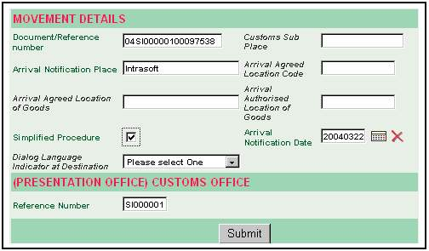
Figure 8-23 Arrival Notification Details
Step 2: | With the required fields completed, the Trader can click on the En Route Events function located on the Trader Root. This menu/screen is used for recording Incidents and or Transhipments and it is Mandatory when the information on Incidents or Transhipments is registered at the Office of Departure. If the Already in NCTS or Incident fields are checked, certain fields become Mandatory by dependence.  Thus, and depending on the specific requirements of a movement, the Trader should proceed to enter data or leave the fields blank. The respective fields are described below in Table 8-24 and are also shown below in Figure 8-24.

Field Name | Format | Condition
En Route Events
Place | Alphanumeric (35 characters maximum) | Mandatory
Country Code | Dropdown | Mandatory
CTL Control / This group is Mandatory
Already in NCTS | Check-box | Mandatory
Incident / This group is Optional
Incident | Check-box | Mandatory
Incident Information | Alphanumeric (350 characters maximum) | Optional
Endorsement Date | Pop-up | Optional
Endorsement Authority | Alphanumeric (35 characters maximum) | Optional
Endorsement Place | Alphanumeric (35 characters maximum) | Optional
Endorsement Country | Dropdown | Optional
Table 8-24 En Route Events – Part 1

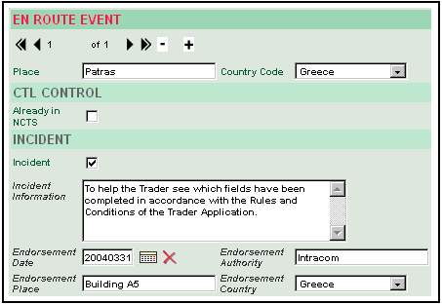
Figure 8-24 En Route Event

Step 3: | With the required fields completed, the Trader must complete the remaining required fields in the En Route Events menu/screen.

Field Name | Format | Condition
Seals Info
This group is Optional
Seals Number | Numeric (4 characters must be entered) | Mandatory
Seals ID
Seals Identity | Alphanumeric (20 characters maximum) | Mandatory
Transhipment / Optional Group
When a transhipment has occurred then either New Transport Means Identity and New Transport Means Nationality or New Container Number or both must be used.
New Transport Means Identity | Alphanumeric (27 characters maximum) | Optional
New Transport Means Nationality | Dropdown | Optional
Endorsement Date | Pop-up | Optional
Endorsement Authority | Alphanumeric (35 characters maximum) | Optional
Endorsement Place | Alphanumeric (35 characters maximum) | Optional
Endorsement Country | Dropdown | Optional
Containers / Optional Group
Container Number | Alphanumeric (17 characters maximum) | Mandatory
Table 8-25 En Route Events – Part 2
Once these fields have been completed, the resultant bottom part of the En Route Events menu/screen should resemble the example shown below in Figure 8-25.

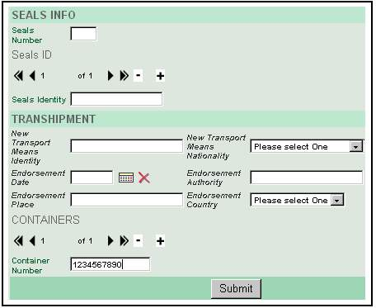
Figure 8-25 Seals Info

Step 4: | With all the required fields completed in the two Input Arrival Notification menus/screens, the Trader should click on the Submit button. This action will submit the Arrival Notification to the Customs Office. If the User has made an error during data input, he/she will be prompted with an error message.  The error message, as shown below in Figure 8-26 is the second of the two types of error messages, as described above in Step 3 of Section 7.2.1.5.2. This particular error message is an XML Validation Error Message, whereas the one shown above in Figure 7-21 is an Error Message.

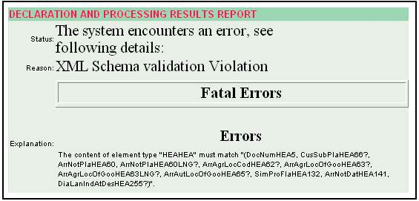
Figure 8-26 Arrival Notification Error Message

Once the Trader has corrected the error in accordance with the message displayed, he/she should click on the Submit button once again. If the Trader Application does not find any further errors, the Trader will be prompted with message. As shown below in Figure 8-27, this message will state that the Submitted Arrival Notification procedure was accepted.

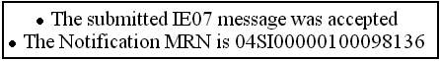
Figure 8-27 Arrival Notification – Message Accepted

Administration
This section provides the Administrator with the execution procedures, fields and functions for the successful management of the Traders at the Office of Departure and the Office of Destination.

Administration Route
Currently the Administration Root exists in the following schema as described below. However, as mentioned above in Sections 7.1 and 8.1, and because the Trader Application is dynamic, this Trader Root is also subject to change during the course of its lifetime.

Principal Folder | Sub-Folder | Execution Activity
Administration | Traders Details | Traders Details:  Provides a screen with the following details: Trader ID, Description, Address, Zip (Post) Code, City, C Code and Traders Groups fields. This information is described in more detail below in Section 9.2.2.  The screen details as they will appear are shown on the right hand side of Figure 9-36 with the title View Trader.
 | User Management | Create New User:  Provides a screen with the Trader ID, User Login, Password, Verify Password, Full Name, Expiration Date, E-Mail and Group fields.  The details as they appear on screen, are shown below in Figure 9-28 and described in more detail in Section 9.2.1.
Manage Existing Users:

Provides a screen with the following details: Entry, User ID, Full Name, E-Mail, Trader ID, User Group and Expiration Date.
 | User Group Management | Create New Group:  Provides a screen with Trader ID, Group ID, Description and State fields, as shown further below in Figure 9-35
Manage Existing Group:

Provides a screen with the following details: Entry, Group ID, Group Description, Group State and Trader ID, as shown below in Figure 9-32.

Administration Function Buttons
The additional Function buttons included below are only applicable for the Administrator.

Function | Description
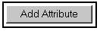 | Adds the selected Attribute from the Dropdown field, as shown below.  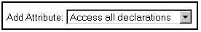  As shown below, the result will appear with a Remove Attribute button on the right hand side of selected Attribute.  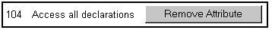
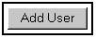 | Adds the Full Name of a User selected from the Drop-down command, as shown below.  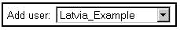  A Remove User button is inserted on the right hand side of selected User and as shown below, the User Login Name becomes a hyperlink on the left hand side of the user's Full Name. This hyperlink enables the Administrator to Edit the User Details.  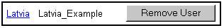
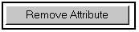 | Removes the selected Attribute and its corresponding Remove Attribute button from screen.
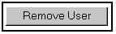 | Removes the selected Attribute, User Login Name hyperlink and its corresponding Remove User button from screen.

Example Administration Execution Procedures

Create New User
To create a new Trader, the Administrator should select the following path: Administration/User Management/Create New User. This action will present the Administrator with the Create New User screen. As shown below in Figure 7-11, there are 3 types of fields that follow the same conventions as described above in Section 5.3.4; and they are:

- Read Only;
- Mandatory;
- Optional.

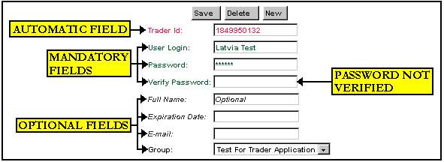
Figure 9-28 Create New User

The Administrator should enter the required information into all the Mandatory fields and any of the Optional fields, and then click on the Save button. For the purpose of this example, the Verify Password was not verified, so that the Administrator can see the resultant error message, as shown below in Figure 9-30.

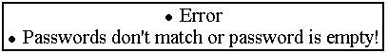
Figure 9-29 Create New User – Error Message

If the Administrator has generated an error message, he/she should click on the Back button and re-enter the respective details.

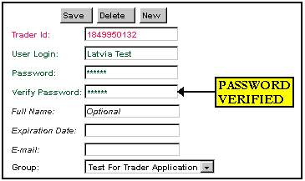
Figure 9-30 Create New User – Correction
As shown below in Figure 9-32, when all the details are correct a message will appear stating that the Create New User execution procedure was successful.

Figure 9-31 Create New User - Success
Note: When the Administrator creates an additional New User's, he/she must ensure that the User Name and Passwords are completely different for each new entry. If this is not the case, the Administrator will be prompted with an error message, and he/she will have to re-enter the details once again.

Manage Existing Group
To Manage an Existing Group, the Administrator should select the following path: Administration/User Group Management/Manage Existing Group. This action will present the Administrator with the Found Entries, as shown below in Figure 9-32.

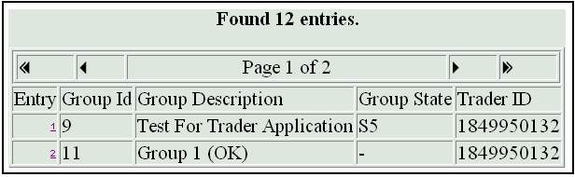
Figure 9-32 Manage Existing Groups

Once this screen is displayed, the Administrator should click on the hyperlink number in the column Entry for the Group he/she wants to select. This action will present the Administrator with the groupsmanage.Manage_Groups screen, as shown below in Figure 9-33.

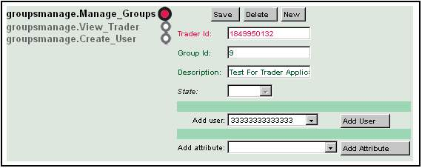
Figure 9-33 Managing Groups
In the Manage Groups screen, the Administrator will observe that the Mandatory fields contain the previously entered information when the file was created. The Administrator will notice that he/she can Add User's and Add Attributes to the Manage Groups screen. To execute this procedure, the Administrator should select the Add User and/or Add Attribute dropdown fields, as described above in Section 9.1.1.
In the example below in Figure 9-34, the Administrator will observe that one User and one Attribute button have been added to the Manage Groups screen. Further, as described above in Section 9.1.1, the corresponding Remove buttons have also been inserted.

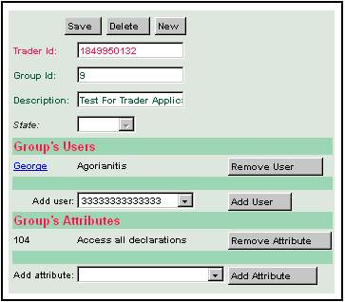
Figure 9-34 Add User/Attribute
If the Administrator clicks on the Groups User hyperlink, he/she will be presented with Edit Users screen, as shown below in Figure 9-35. This screen follows the same conventions as described above in Section 9.2.1, Create New User.

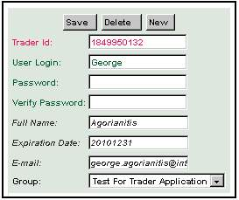
Figure 9-35 Manage Users
Alternatively, from the Trader Root, the Administrator can select the groupsmanage.View_Trader and groupsmanage.Create_Trader, as shown below in Figure 9-36. The Administrator will observe that he/she can also proceed from the View Trader to the Create Group screen, by clicking on the Create Group hyperlink.

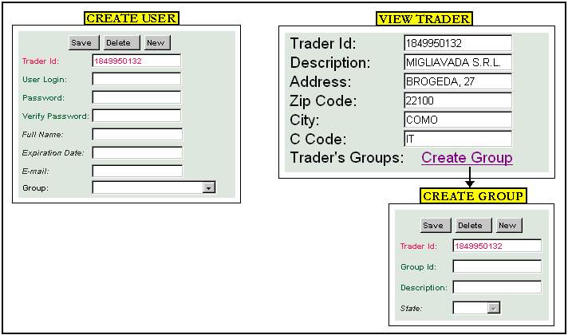
Figure 9-36 View/Create Trader

THe exact URL to be used will be provided by the NCB.

